|  |  |
| --- | --- |
| Name: Sayyed Sohail Rashid | Course Name: DC-LAB |
| Class: BE-CO | Batch: 01 |
| Roll no: 18CO48 | Experiment No: 08 |

Aim : To Implement the Inter process communication using java.

Code:

Server.java

import java.util.*;

import java.io.*;

import java.net.*;

public class Server {

public static void main(String args[]) throws Exception{

//Server server = new Server();

ServerSocket MyServer = new ServerSocket(5000);

Socket ss = MyServer.accept();

DataInputStream din =new DataInputStream(ss.getInputStream());

DataOutputStream dout=new DataOutputStream(ss.getOutputStream());

BufferedReader br=new BufferedReader(new

InputStreamReader(System.in));

Server server = new Server();

String str="",str2="";

int sum = 0;

while(!str.equals("stop")){

str=din.readUTF();

if(str.equals("stop"))

break;

sum = sum + Integer.parseInt(str);

}

dout.writeUTF(Integer.toString(sum));

dout.flush();

din.close();

ss.close();

MyServer.close();

}

}

Client.java

import java.io.*;

import java.util.*;

import java.net.*;

public class Client

{

public static void main(String args[])throws Exception

{

String send="",r="";

Socket MyClient = new Socket("127.0.0.1",5000);

DataInputStream din=new

DataInputStream(MyClient.getInputStream());

DataOutputStream dout = new

DataOutputStream(MyClient.getOutputStream());

Scanner sc = new Scanner(System.in);

while(!send.equals("stop")){

System.out.print("Send: ");

send = sc.nextLine();

dout.writeUTF(send);

}

dout.flush();

r=din.readUTF();

System.out.println("Reply: "+ r);

dout.close();

din.close();

MyClient.close();

}

}

Output:

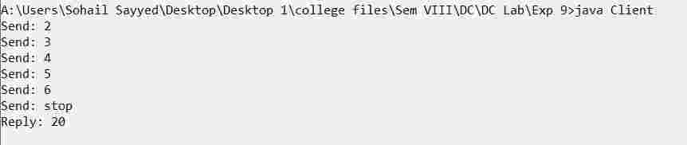

Conclusion:

We have started the Server and send messages until Client send the stop message and get the reply.